Assignment: python programming for GUI development

**Name**: D. karthik.

**Register Number**:192311320

**Department**: computer science engineering

**Date of submission**:26/08/2024

**Problem 5: AIR Pollution API**

**Scenario:**

We are forecasting the air pollution and historical air pollution data. Air pollution refers to the presence of harmful substances in the air that can pose risks to human health, ecosystems, and the environment. we are finding to the pollutant concentrations of n02, co2,e.t.c.

**Tasks:**

**1**.to forecast the air pollution API includes both air quality index and indices for co2, no2,no,o3,so2,pM10.

**2.**implement the Model the data flow for fetching air pollution statistics from an external API and displaying it to the user.

**3.** Implement a Python application that integrates with a air polution statistics API

(e.g., no2,co,etc..) to fetch real-time data.

**5.** Allow users to input a region (country, state, or city) and display the

corresponding air pollution statistics.

**Deliverables:**

**•** Data flow diagram illustrating the interaction between the application and the API.

**•** Pseudocode and implementation

**•** Documentation of the API integration and the methods used to fetch and display the

data.

**•** Explanation of any assumptions made and potential improvements.

**Solution:**

**Real time forecasting air pollution:**

**1.Data flow diagram:**

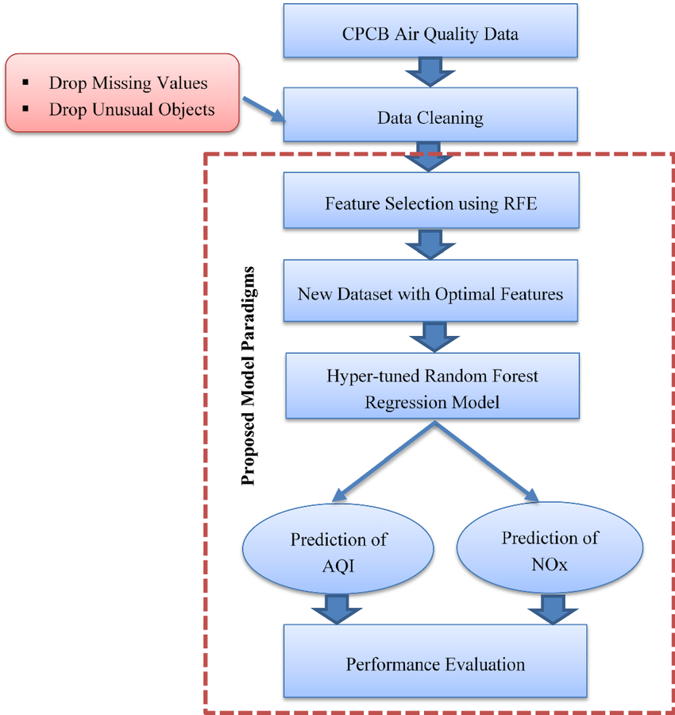

**2.Implementation:**

**import requests**

**def get_air_pollution(api_key, lat, lon):**

**# Fix the typo in the URL by removing the space**

**url = f"http://api.openweathermap.org/data/2.5/air_pollution?lat={lat}&lon={lon}&appid={api_key}"**

**response = requests.get(url)**

**data = response.json()**

**return data**

**# Replace with your latitude and longitude**

**api_key = "d7d1d230b12fa8ee5e1dccfbc95e8189"**

**lat 49.28**

**lon 123.12**

**data = get_air_pollution(api_key, lat, lon)**

**print("Air Pollution Data:")**

**print("AQI:", data["list"][0]["main"]["aqi"])**

**print("CO:", data["list"] [0] ["components"]["co"]) print("NO:", data["list"][0]["components"]["no"])**

**print("NO2:", data["list"][0]["components"]["no2"])**

**print("03:", data["list"][0]["components"]["03"])**

**print("502:", data["list"][0]["components"]["so2"])**

**print("PM2.5:", data["list"][0]["components"]["pm2_5"])**

**print("PM10:", data["list"][0]["components"]["pm10"])**

**print("NH3:", data["list"][0]["components"]["nh3"])**

**Air Pollution Data:**

**AQI: 2**

**CO: 383.85**

**NO: 0.01**

**NO2: 0.24**

**03: 65.09**

**502: 0.11**

**PM2.5: 2.75**

**PM10: 2.83**

**NH3: 1.09**

**3.Display the Current information:**

**Enter latitude:**149.0

**Enter longitude:**123.28

**4.User input:**

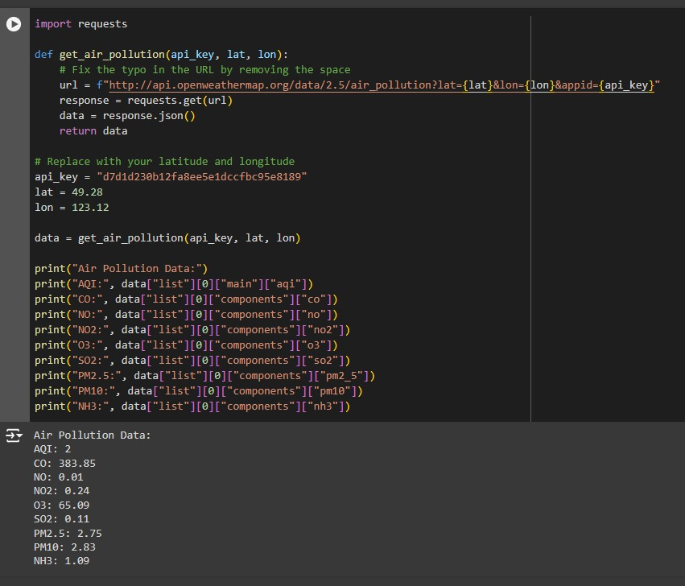

**5.Documentation:**

Air pollution concentration refers to the amount of a particular pollutant present in the air at a specific location and time. This concentration is typically measured in units such as micrograms per cubic meter (µg/m³) or parts per million (ppm) for gases. Here's a general overview of the key concepts and documentation you might need:

**1. Types of Pollutants:**

**Particulate Matter (PM):** Includes PM2.5 (particles smaller than 2.5 micrometres) and PM10 (particles smaller than 10 micrometres).

**1.Gaseous Polluants:**

**2.Ozone (O₃)**

**3.Nitrogen Dioxyde (NO₂)**

**4.Sulfur Dioxyde (SO₂)**

**5.Carbon Mon oxide (CO)**

**6.Volatile Organic Compounds (VOCs)**

**2. Measurement Methods:**

**1.Gravimetric Method:** Used for measuring particulate matter by collecting particles on filters and weighing them.

**2.Continuous Monitoring:** Uses sensors and analyzers to continuously measure pollutants like O₃, NO₂, and CO.

**3. Regulatory Standards:**

**1.World Health Organization (WHO) Guidelines*:** Provides global air quality guidelines for various pollutants.

**2.National Ambient Air Quality Standards (NAAQS)*:** In the U.S., these are set by the Environmental Protection Agency (EPA) for six major pollutants.

**4. Data Representation:**

**1.Concentration Data:** Typically presented as average concentrations over specific periods (e.g., hourly, daily, annual averages).

**2.Air Quality Index (AQI):** A standardized index that converts pollutant concentrations into a scale that indicates the health risk level to the public.

**5. Sources of Pollution:**

**1.Natural Sources:** Includes wildfires, volcanic activity, and dust storms.

**2.Anthropogenic Sources:** Includes vehicle emissions, industrial processes, agricultural activities, and residential heating.

**6. Health and Environmental Impact:**

**1.Short-term Effects:** Respiratory and cardiovascular issues, irritation of eyes and throat.

**2.Long-term Effects:** Chronic respiratory diseases, lung cancer, heart disease.

**3.Environmental Effects:** Acid rain, eutrophication, damage to vegetation and wildlife.

**7. Monitoring Networks:**

**1.Government Agencies:** Most countries have national agencies that monitor air quality (e.g., EPA in the U.S., DEFRA in the UK).

**2.International Networks:** Organizations like the European Environment Agency (EEA) and the United Nations Environment Programme (UNEP) provide global air quality data and guidelines.

**8. Data Collection and Reporting:**

**1.Stationary Monitoring Stations**: Fixed locations that continuously measure air pollutants.

**2.Mobile Monitoring:** Vehicles equipped with sensors to measure pollutants across different locations.

**3.Remote Sensing:** Use of satellites to measure air pollution on a large scale.

**9. Mitigation and Control Measures:**

**1.Emission Reduction:** Implementation of cleaner technologies and stricter regulations on emissions.

**2.Urban Planning:** Designing cities to reduce traffic congestion and promote green spaces.

**10. Research and Development:**

**1.Pollution Modelling:** Using computer models to predict air pollution levels and identify potential sources.

**2. Studies:** Research on the health impacts of exposure to various pollutants.

**3.Innovative Technologies:** Development of new technologies for air quality monitoring and pollution control.

**11.Key References:**

**1.WHO Air Quality Guidelines:** Global update 2021.

**2.EPA Air Quality Criteria for Particulate Matter:** U.S. EPA, 2019**.**

**3.European Environment Agency (EEA) Air Quality Reports** Latest annual reports on air quality in Europe.**:**